Adding Report level changes in explore opportunity. Hierarchies are disabled based on report level and preferences also should save and apply report level back. Report level prior to selected one should also be disabled.
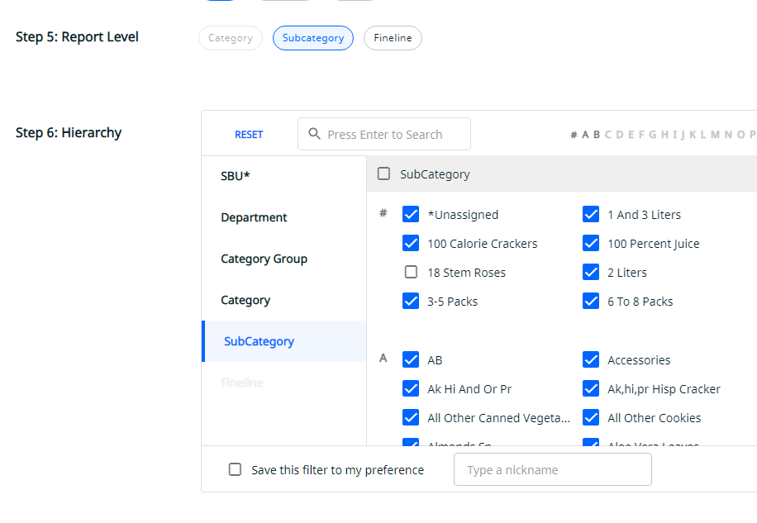

Supplier scorecard: Adding LAA markets (Argentina, China, Japan, CAM, Chille). Disabling hierarchies based on different market and also changing verbiage below hierarchy table for each market
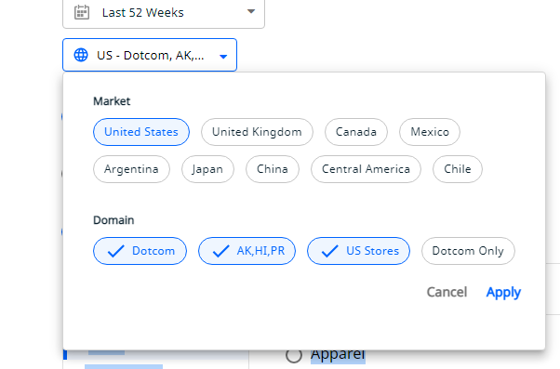

Apache vs NGNIX exploration: Document is uploaded separately

Explore opportunity : added Unbranded and GS_Import for Canada and Mexico
